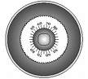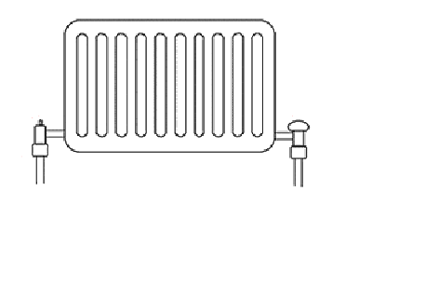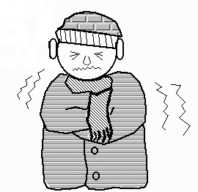
Thyroid

TSH

T₄ & T₃
T₄
&
T₃
Hypothalamus/Pituitary gland
-ve feedback
T₄ & T₃ turns down the Pituitary gland (thermostat)
+ve feed forward
TSH increases the activity of the thyroid gland (boiler)

